Low Level Design (LLD)

Last date of revision: 01/03/2023

Paramita Pal

# Document Version Control

|  |  |  |  |
| --- | --- | --- | --- |
| Date Issued | Version | Description | Author |
| 20th February,2023 | **1.1** | **First Draft** | Paramita |
| 21st February | **1.2** | **Workflow process added** | -Do- |
| 22nd February | **1.3** | **Constraints and Exceptions added** |  |
| 23rd February | **1.4** | **Key performance indexes added** |  |
| 24th February | **1.5** | **Flowcharts added denoting input and output** |  |
| 24th February | **1.6** |  |  |
| 25th February | **1.7** | **Added dataset overview and updated user I/O flowchart.** |  |
| 26th February | **1.8** | **LLD Structure ready for submission** |  |

**Contents**

Document Version Control 2

Abstract 4

1 Introduction 5

1.1 Need of a Low-Level Design Document: 5

1.2 Scope 5

1.3 Constraints 5

1.4 Risks 5

1.5 Out of Scope 5

2 Technical specifications 6

2.1.2 Input schema 6

2.4 Database 6

3 Technology stack 6

4 Proposed Solution 7

5 Model training/validation workflow 8

6 User I/O workflow 10

7 Exceptional scenarios 11

8 Test cases 12

9 Key performance indicators (KPI) 13

# Abstract

Books have long been the best friend of the civilized society. Apart from providing knowledge, it is the propagation of communication that transcends into an intellectual and psychological broadening of the minds of the superior species, the humans. Most printed material have opened new domains of evolution, ideas, research, and a barter of information. The Online book shop carries the tradition of a better improved society that chooses to buy books, trace and track readers as well as buyer-sellers to interact.

The system is primarily an eCommerce application, that is a mega Book mart intended to connect anybody and everybody interested in reading in print. The age-old tendency to widen view with reading is being enhanced by the system.

The system connects people who are book collectors and often feel the necessity to lend their books in exchange of money to people who might carry on their legacy. In a scenario of recent trends to read pdf’s and rely on online materials, the system demands commendable respect as it tends to connect readers across the globe, online.

# Introduction

## Need of a Low-Level Design Document:

The low-level Design Document contains a detailed description of the application to be developed. Low level designing contains bulky data and document tto delve into details the development phase. The LLD is a reference document for developers, reference material with all the technicalities involved.

Low level designing aims at the technical detailing of the project. It consists of the algorithm and details about classes/ methods to achieve the required functionality in terms of business requirements. The Low Levell design aims to achieve the functional and non-functional requirements by giving a technical roadmap for it. The document divided into various sections to make the code reusable and scalable.

The main objective of the project is to make a connection between the people who have a demand for books and those who need the books.

This project shall be delivered in a manner that suggestive changes may be easily implemented without disturbing the already existing data.:

## Scope

This software system will be a Web application This system will be designed to locate all interested readers to find their books easily as well as those who have hold on to resources, to share it.

In the application, registered users will be given a chance to get hold of books of their interest in various formats and from most of the domains.

Books may be bought and sold likewise. Books may be acquired in physical form in hardcover or as online pdf versions.

## Constraints

A few functionalities could not be implemented.

* The system suffers from the drawback of not being overtly tested. System testing and Loop testing were performed but not all functionalities could be tested.
* The buying and Lending of Books portal, does not give a vivid reasoning of marked price of books. The cost of purchase or lending being set on common market standards.
* Books from all domains and all necessities could not be put on the portal.
* No guarantee regarding the old books and their authenticity may be provided by the system.

## Risks

Document specific risks that have been identified or that should be considered.

## Out of Scope

Delineate specific activities, capabilities, and items that are out of scope for the project.

# Technical specifications

## 2.1.2 Input schema

## 2.4 Database

System needs to store every request into the database and we need to store it in such a way that it is easy to retrain the model as well.

1. The User chooses the disease.

2. The User gives required information.

3. The system stores each and every data given by the user or received on request to the database. Database you can choose your own choice whether MySQL.

# Technology stack

|  |  |
| --- | --- |
| **Front End** | HTML/CSS/JSP/Java |
| **Backend** | mysql |
| **Database** | mysql |

# Proposed Solution

refer: <https://arxiv.org/abs/1808.04928>

Based on the actual research paper, if we are using history of the patient to predict the future then we might want to consider using LSTM. However, drawing a baseline in the form of some Machine Learning algorithm would be helpful. Why making a baseline model important? Well, to compare the performance of our actual model, let say LSTM in this case, is very important to ascertain that we are in the right direction as if performance of LSTM is not better than the baseline model then there is no point of using LSTM.

1. Baseline Model: Logistic Regression, since this is a classification problem.
2. Actual model: LSTMs.

# Model training/validation workflow

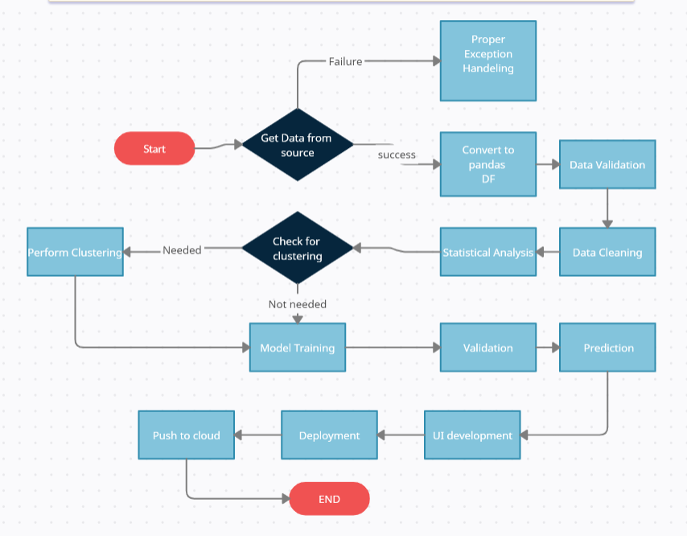

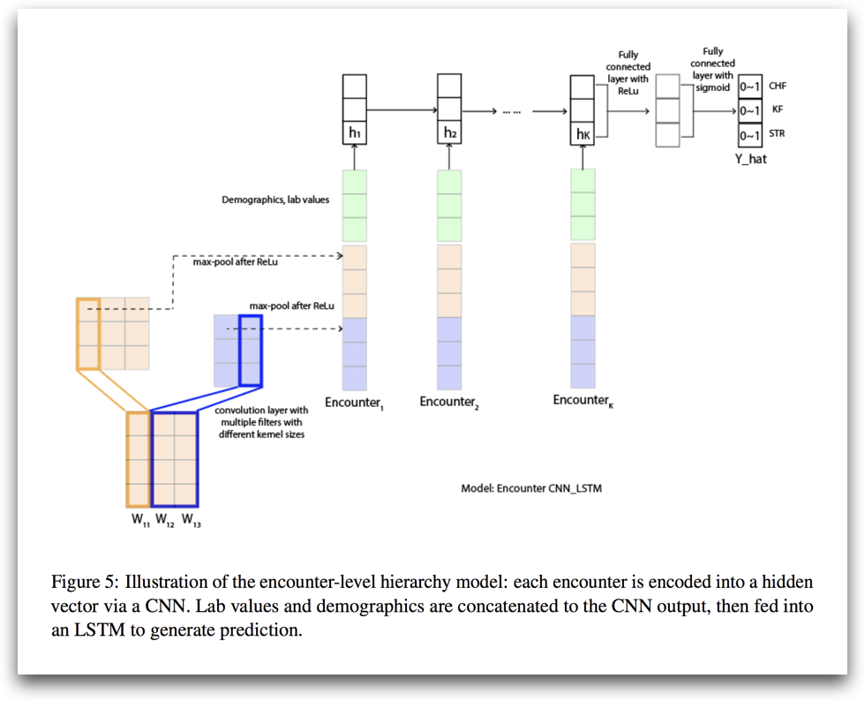

# User I/O workflow

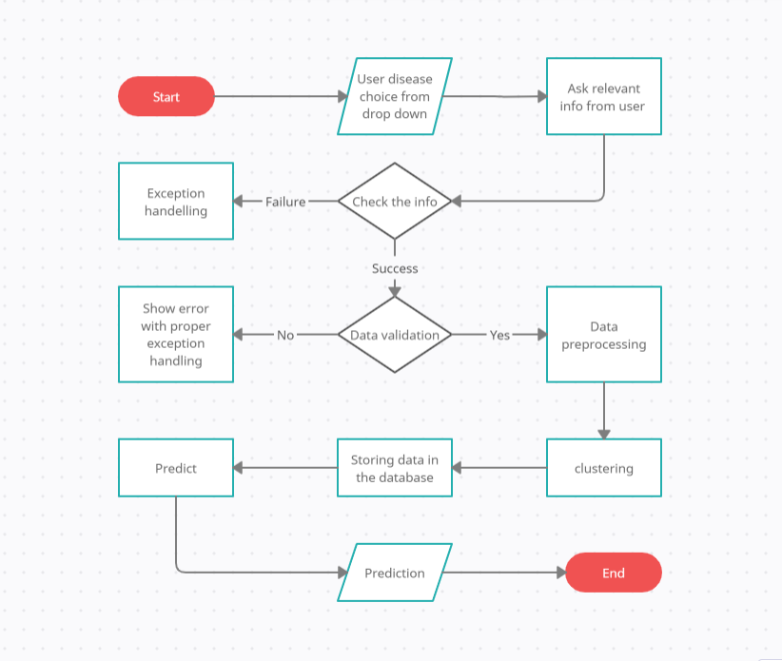

# Exceptional scenarios

|  |  |  |  |
| --- | --- | --- | --- |
| Step | Exception | Mitigation | Module |
| 18th May 2020 | 1.1 | First Draft | Amit K Gupta |
| 20th May 2020 | 1.2 | Added Workflow chart | Amit K Gupta |

# Test cases

|  |  |  |  |
| --- | --- | --- | --- |
| Test case | Steps to perform test case | Module | Pass/Fail |
|  |  |  |  |

# Key performance indicators (KPI)

* A new idea of book promotion using the application
* Improvement of self-studying habit
* Number of times a patient visits the hospital.
* Time between symptom onset and detection of illness/visit to hospital.
* Immunity of patient (based on previous illnesses).
* Vaccines the patient has taken.
* Length of stays in hospital.